6. Temporary modulation for exercise and lighter (in-)activity V 4.1
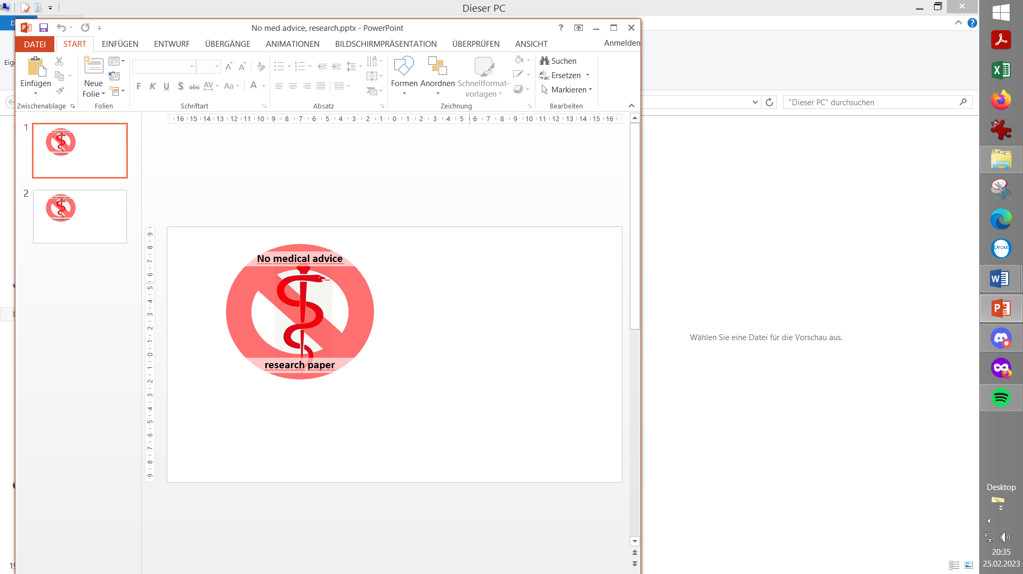
Please note that with autoISF you are in an early-dev. environment, where the user interface is not optimized for safety of users who stray away from intended ways to use. Good safety features exist, but these are only as good as the development-oriented user understands and implements them. This is not a medical product, refer to disclaimer in section 0

6.1 Dynamic iobTH and sensitivity ratio
Available related case studies:
Case study 6.2: Biking day with hi carb lunch; ………………… DIY cockpit

6.1.1 Manual (direct) iobTH modulation
6.1.2 Automations for iobTH modulation
6.1.3 Dynamic iobTH
6.2 Temp. % profile switch
6.3 DIY cockpit based on User action Automations
6.4 Mastering the exercise after meal challenge
6.4.1 Manual mode
6.4.2 DIY cockpit button for User action Automation
6.4.3 Laissez-faire mode
6.5 Activity monitor based on step-counter

Preliminary remarks

For insights how to generally manage various kinds of exercise, listen-in this reference by looping pioneer and sportswoman Dana Lewis: https://bit.ly/DC1_631 (starts around minute 05:30), or read up in: https://diyps.org/.../how-to-exercise-when-exercise-is...
Note that this paper focusses on the challenges of exercise management in a Full Closed Loop system. It is no easy read because it attempts to describe all options to deal with various types of exercise.
Looking at case studies that relate to your kinds of exercise might be easier to digest than working your way through all the options laid out in this section.
- Please report your experience by publishing a case study.

Fortunately:
- If you do only light exercise, the Activity Monitor (section 6.5) might be all you need, nothing else from this section 6.
- For any of your (occasional or regular) exercise events, you can set any of them up at your leisure, later, one at a time – and activate the one you need as you approach exercise time.
- Also (and especially in your first weeks of FCL; with focus on meal management), you can always exit into Hybrid Closed Loop or even Open Loop, and manage certain exercise the way you always did before.

As long you were not able yet to define better ways, you should always be able to manage A bg dropping during sports with extra snacks (keep those at hand).
Staying in contact with the related discord/github community should help greatly to find suitable ways to manage your type(s) of exercise

6.1 Dynamic iobTH and sensitivity ratio in „exercise mode“

iobTH is a iob threshold you can set, above which AAPS will no longer deliver additional SMBs.
- This overrides the SMB management via even/odd bg target differentiation).
- Regarding by how much “the last SMB” may shoot over iobTH, see section 2.4.

For exercise, we like to limit how high iob can go, therefore automatic “dynamic” reduction of your set iobTH (= iobMAX x iobTH%) is a benefit, notably as you can individually tune it.
In autoISF 3.0 and later, a setting for iobTH is made in AAPS preferences, defined there as fraction (e.g. 0.6) of your set maxIOB:
/OpenAPS_SMB/autoISF_settings/Full_Loop_settings: iob_threshold_percent,
=> default iobTH = iobMAX x iob_threshold_percent

So, while iobTH could also be modulated via iobMAX, we mostly adapt the iob_threshold_percent, to do that.

In the following, 3 principal avenues to temporary adjusting iobTH to your exercise requirements are described:
- Manual intervention (6.1.1)
- making use of individually defined Automations (6.1.2), and
- relying on the automatic dynamic adjustments coming with autoISF (6.1.3) .
The author experimented with all of them, but rarely needs manual intervention because the automatic “dynamic” adjustments work pretty well, after some individual tuning (see e.g. case study 6.2).
In any case, it is good to educate yourself about manual tweaking options, should the need arise.

6.1.1 Manual (direct) iobTH modulation

„Manual“ routes to directly change iobTH would be
- changing the setting for the new parameter „iob_threshold_percent „
- or changing the setting for iobMAX
in /Preferences.
This is not a preferred route for temporary adjustment, because it is not easy accessible with just a button stroke, and it would not automatically revert to your prior setting, after use. A better solution that can achieve nearly the same is: to construct your own “DIY cockpit” button to change iobTH% from the AAPS main screen, see next section.

6.1.2 Automations for temporary iobTH modulation

You can define Automations that set a different iobTH% under pre-defined conditions
In a variation of this idea (if your Automation has the User Action box ticked), you get a grey button into your AAPS home screen, from which you can activate that changed iobTH manually (“DIY cockpit”, as was already presented in section 5.2.2.3)..
Note that your Automation defines the iobTH that your loop shall use in place of the previously set iobTH:
- it will still be modulated further if %profile and TT are set (see below)
- it will overwrite the iobTH% you had set in /preferences!

Caution: A different iobTH% (same goes for bgAccel_ISF_weight) can not be set temporarily in Automations (i.e. a duration cannot be attached). You must define a suitable additional Automation that must be active in tandem, and restores the prior set iobTH% (or bgAccel-ISF_weight) later again. Else, once your Automation sets in, it will forever shift this important parameter setting!
If for instance you have several Automations that, in combination with a set elevated TT also set a lower iobTH: Don’t be fooled, the duration only applies to the TT. You need an extra “tandem” Automation for all of them.
Example: My Automation that restores my prior set profile iobTH%: I picked out the highest of the lowered iobTH values that any of my Automations can set (45 percent was the highest “of the low ones” in my case), and then I can automatically restore to my prior 60% via this one:

Caution: Watch out for another potential stumbling block, because many Automations only work under the condition that no TT is already running.

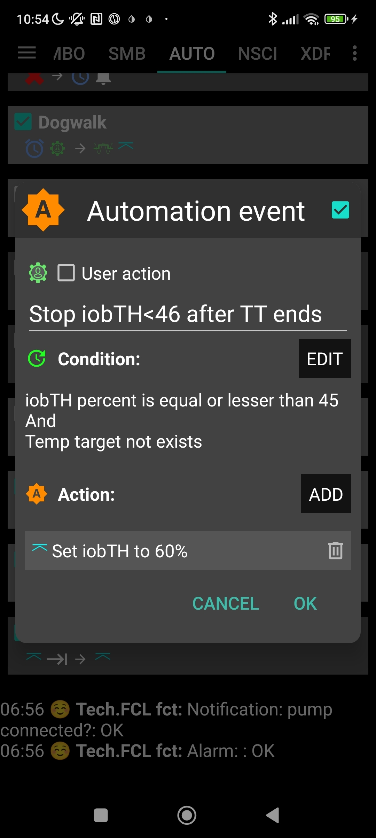

As temp. changing iobTH is quite tricky to automate, it is the author’s preferred route to only indirectly modify it – see next section:

6.1.3 Dynamic iobTH: iobTH modulation via setting a temp. glucose target (TT)

In AAPS/Preferences, set “High TT raises sensitivity = TRUE”. Then, setting an elevated temporary glucose target (TT), decreases iobTH by the same factor as it increases sensitivity (as it “softens” ISF). Both measures decrease insulin that the loop will give.
Likewise, In AAPS/Preferences, set “Low TT lowers sensitivity = TRUE”. Then, setting a low temporary glucose target (e.g. a EatingSoonTT of 74 mg/dl), elevates iobTH by the same factor as it also sharpens (lowers) the ISF. The loop will give more insulin.

6.1.3.1 How does automatic sensitivity and iobTH adaptation work in the exercise mode?
When. additionally. the exercise button is ON (lit yellow), iobTH gets reduced particularly strong, and ISF is particularly weakened (as desired for exercise). That effect is the stronger (ISF gets the weaker, iobTH the lower), the lower you set the half-basal exercise target for your exercise mode in AAPS/preferences/OpenAPS SMB:
The following table shows, for a profile target of 100 mg/dl, how the set …
- half_basal_exercise_target you set in AAPS/preferences/OpenAPS SMB…
Choose a low number if you later want a high dynamic range of sensitivity modulation Lower half-basal exercise target = lesser insulin delivered
- …and current exercise TT (that you set on the day you do the respective exercise, with an eye on how you wish sensitivity auto-adjusted)…
Higher TT = lesser insulin delivered
… determine the effective sensitivity ratio:
Half basal ex.target | 180 | 150 | 120
TT | sens.ratio | sens.ratio | sens.ratio
100  100 = profile target | 1 | 1 | 1
120 | 0,8 | 0,71 | 0,5
140 | 0,67 | 0,56 | 0,33
160 | 0,57 | 0,45 | 0,25
180 | 0,50 | 0,38 | 0,20
The exact calculation for any combination of profile target, set TT, and half-basal_exercise_target is given in the autoISF Quick guide (see section 3.3).
Note that:
- temp. basal = profile basal * sens.ratio
Example: At a half-basal_exercise_target of 120, setting a TT of 120 gives only half (0.5) of profile basal (hence the name of the parameter)

- temp.ISF = profile ISF / sens.ratio
- temp.iobTH = set iobTH * sens.ratio
Whereas in “vanilla” AAPS the sens ratio is simply coming from you (manually), or from Autosens (automatically) setting a temporary profile sensitivity other than 100% (and in the special case of dynamicISF with additional effects on ISF), here, in autoISF, we have strong, non-linear, and user scaleable effects on the sens.ratio.

6.1.3.2 How you recognize the real-time iobTH, and “aggressiveness” status of your FCL loop in general
Rather than bothering with the math, you can just look into your AUTO ISF tab where your selected temporary settings put your iobTH, and the modified ISF (called sens):

The valid “effective iobTH” can also be seen in the AUTO ISF tab, see example (for a TT=144 and exercise button clicked);
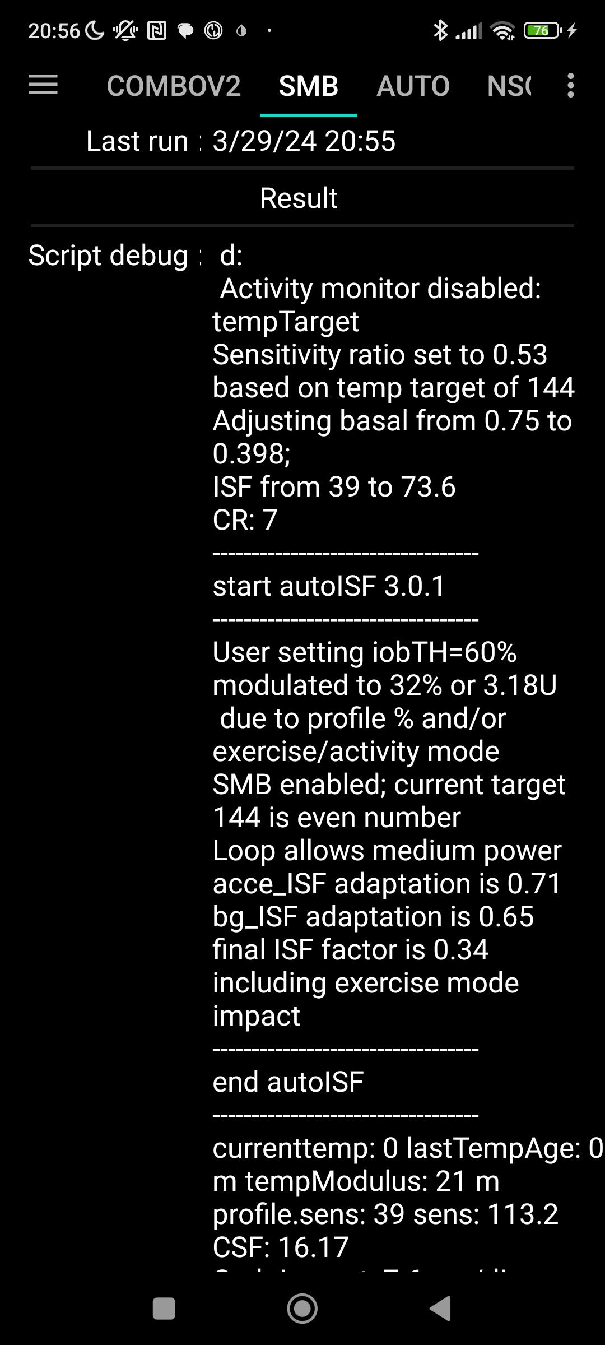

Same, with (via top left button in AAPS home screen) additionally 70% profile applied:
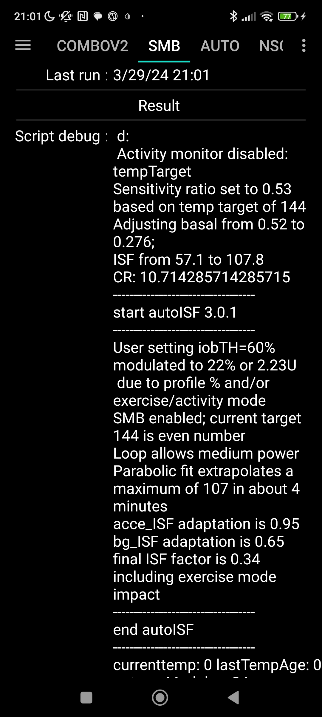

0.75 profile basal * 70% = 0.52 temp.profile basal

39 profile ISF / 70%
= 57 temp profile ISF

0.52*0.53=
=39 / 0.53
0.75 *0.53 =
=57 / 0.53

= 60%*0.53*70%
60% *0.53 =

=39 / 0.34 0.340.340.340,340.53
profile.sens 39 sens: 162 = 39 / (0.34 * 70%)
These examples show that, by just setting an exercise TT and a typical exercise profile% (two super easy “interventions” via the top buttons on our AAPS main screen, turning yellow in response as an easy “reminder” we are in a special mode), the iobTH will be automatically very sharply reduced, in our example, to: . about half just by the TT; and further to about 1/3, by the % setting:
Exercise button ON + …. | …. TT=144 | … TT=144 AND 70% profile
iob TH = 6 U (60%) | iobTH = 3,18 U (32%) | iobTH =2,23 U (22%)
profileISF = 39 mg/dl/U | ISF = 73,6 | ISF = 107
autoISF modulated ISF *) | ISF = 113,2 | ISF = 162
*) data are from a situation where there is no sharp bg rise, so autoISF does not suggest increased aggressiveness

In the example fgiven above, the user’s iobTH calculates to 6.0 U, which is 60% of iobMAX of 10.0 U. So, normally, autoISF FCL could give SMBs until iob reached anywhere between 6.0 U and 7.2 U (=6.0 +20%; see section 2.4 at step 2.4: at bg>100, iob can run max. 20% over with “last” SMB). For doing exercise, this window shrinks now to 3.18 – 3.82 U (left, TT-only) or, even to 2.23 – 2.77 U (right, TT AND %profile).
In conclusion, these easy-to-make settings (TT, %profile) automatically provide the same thing like would have been done in Hybrid Closed Loop, where a meal bolus of about 7 U would get cut down to 4 U or even to 3 U, depending on type of exercise.
If you concurrently use QPython 3L and the emulator on your Android phone (see section 11) you need not look into the AUTO ISF tab, but could see more details (~ for the last hour, plus all contributing …ISF_categories from autoISF), in tabular form, on your phone.
The most recent AAPS x autoISF version also allows extra graphs at the bottom of the AAPS home screen on your smartphone, showing the development, and current value, of iobTH,
(Also details on bgAccel-, pp-, bg-, and dura-ISF contributions can be visualized in extra graph).
For i-Phone autoISF users, double clicking on “Statistics” provides some more detailed information (see section 11.3).

6.1.3.3 Customization and-tuning
Try to determine good settings for the kinds of exercise that you engage in:
- Set your half-basal exercise target in /preferences that suits all of them…
- Determine reasonable TTs for each of your intended specific exercises
- Iterate through this a couple of times (whenever you happen to do that exercise).
Remember (“code” for yourself), which TT stands for which exercise type, so that just by setting that TT everything (ISF, iobTH) automatically will provide the lower loop aggressiveness that you need for that specific type of exercise.

When setting a TT please watch out for unintended implications and side-effects:
- Setting a TT often shuts out other Automations. Therefore, choose the duration wisely (and also the sequence, in which all your Automations are listed).
- You always must consciously decide whether you set an even or an odd numbered bg target (TT or profile target). (This is assuming you use, as you should, the even/odd bg target differentiation for SMB on/off).
- 2.1) Pick odd, if you do not want SMBs during exercise. (Despite your softened ISF, and lowered iobTH, SMBs still might „attack“ a sports snack too strongly).
  - However, odd cannot be set too early, when your meal digestion still requires SMBs.
  - Likewise, you might want the option for a few automatically delivered SMBs against unforeseen spikes (e.g. from excitement) also later. In that case, an Automation might sneak in a desired SMB or two via switching from odd to even, just for a couple of minutes, and under a well thought-out set of conditions (that you must find in your data patterns, when you do that kind of exercise that you try to find good settings for),
However, you are probably out of luck because an already set odd (or any) TT would preclude such Automation from kicking in. Then you need to develop additional ideas, another detour, like to first define an Automation that briefly shuts your odd TT down.
- So, defining everything so you really can be happy with oddTT being your prímary way is a quite tricky project you should not under-estimate.
- 2.2) Working with an even TT can be preferable, notably of course if your exercise is one that can get you totally excited, with glucose spikes.
  - While this mode generally does allow SMBs, the loop softens the ISF (by the sens.factor like in the table given above), and will temp. shut SMBs down, when iobTH (which also got lowered by the sens. factor) is exceeded.

Whether odd or even TT is better depends on the kinds of exercise you are doing, and probably depends on the protein and fat load of your meal and snacks, as well.
(3) Timing can be critical as to when you do your exercise announcement, especially relative to a preceding hi-carb meal. Then you want the reduced iobTH in place latest after you received the first SMB. See section 6.4 and case study 6.2
(4) Once you are familiar with the dynamic range of your iobTH,
- after you made your settings, notably set your half-basal exercise target
- knowing the range of TTs and %profile adaptations that you intend to use before/during/after your types of exercise
please confirm or re-consider your iobTH_percent setting in /Preferences, section 2.4.
(5) You always can look the effective iobTH up in the AUTO ISF tab (see screenshots given 3 pages earlier). Also, it is given as a line in an extra graph that is available underneath your main AAPS glucose screen.

6.1.4 Tweaking iobTH

You can use any of the above discussed methods, or also the one that now follows in section 6.2, to further tweak iobTH temporarily, should you see a need.

Also outside of exercise, setting an even elevated TT plus pressing the exercise button gives easy access to significantly reduce aggressiveness of your autoISF loop via a resulting lowered iobTH and, concurrently, elevated effective ISF.
This could be used for instance for 45-60 minutes at low/medium carb snacks, as an alternative to shutting SMBs entirely off via an odd TT.

When exercise follows a meal, it might be smart to use the just discussed tweaking methods right after you felt the sting from the first big Lyumjev SMB. However, we will look at smarter and safer ways for this “exercise after meal” scenario in section 6.5 and in case study 6.2

6.2 Temporary % profile switch

A complementary measure (to setting an elevated TT) that you also can take from the AAPS home screen, is to set a reduced temp.% profile sensitivity.
This setting would multiply with the results in above table and further reduce basal and iobTH (whenever exercise button AND profile button both are yellow).
An example was already given with the 2nd screenshot, 4 pages earlier

Note that temp. reduction of basal will proportionally also reduce the max. allowed size of SMBs (which is two hours worth of basal x SMB_range_extention, see section 2.1)
This is desirable at exercise, albeit seldom needed, because milder ISFs will reduce the requested SMB size, and after the radically lowered iobTH is exceeded, no SMBs will be requested any longer, anyways.

The time windows for doing a profile switch can differ from the time window (duration) of your TT-related exercise settings.
Using all available tools then allows a nearly surgical approach to what you want to achieve for and during your favorite exercise(s).
- Often the %profile modulation is used for several hours if not days to accommodate “long waved” sensitivity changes (See e.g. in case study 6.2).
- Instead, or even additionally, the percentage might be modified for just a couple of minutes, or for one special snack or meal duration, to “nudge” the proportionally modulated aggressiveness of the FCL (see section 5.2.3).

You can prepare yourself for anything you see coming up, or potentially coming up, in your daily life, so, from the comfort of your cockpit (section 6.3;) you get ready for it within just a second or two, doing a few „clicks“.

6.3 DIY cockpit for exercise, based on User action Automations
6.3.1 Basic Settings for Exercise

Coming from FCL with no TT set (the top fields TT and exercise are grey), you best prepare for an intended exercise by pressing the TT field of your AAPS main screen (your looping cockpit; presented in section 5.2).
There, you can freely select TT and duration.

In case you want maximal “softening” effect on basal, ISF, and iobTH, activate also the exercise button in the top middle of your AAPS main screen. It then should turn yellow, to indicate you are in the dynamic exercise mode (color sequence of the top 3 buttons in your AAPS home screen = YYY or GYY).

6.3.2 „Dynamic“ exercise mode off = traditional AAPS exercise mode (YGY)

When the dynamic exercise mode is off (YGY), you still have the instruments for exercise management just as you always had it in the past = a combination of manually softened aggressiveness via setting a temp. %profile change, and orienting corrections towards an elevated TT.
By selecting an odd numbered TT you now have the additional option to shut SMBs temporarily off, too.
In this “YGY” mode, the % temp. set profile is the applied “effective sensitivity” (% ratio)
TT and duration can be entered or changed (= traditional mode to set exercise targets).
The effective iobTH is given in the AUTO ISF tab, or can also be seen in an extra graph below the AAPS home screen glucose chart.
TT and % profile will also show on the yellow labels of the neighboring %profile (left top of AAPS home screen) and TT (right side), respectively.
The middle (exercise) field remains grey because the automatic sensitivity tuning (that would use TT and half-basal exercise target) are off.

6.3.3 Dynamic exercise mode ON (GYY or YYY)

By pressing the yellow exercise button on the AAPS home screen, you have the option to switch the dynamic exercise mode ON, in which case the middle field/exercise button of your AAPS main screen will go from grey to yellow.

6.3.4 Dynamic exercise mode ON plus %profile change (YYY)
(with all three top buttons of your FCL cockpit yellow). This maximally will soften aggressiveness,
Maximal softening happens only when <100% profile.
A >100% profile is not used for exercise typically, and would counter-act the softening from the elevated TT.

It is advisable to find good settings primarily within the dynamic exercise mode (i.e. via your half-basal exercise target, and TTs you select for various kinds of exercise).
Use additional profile switches mainly complementary as needed. notably to provide for other, „longer waved“ effects (e.g. into the following night), regarding changed insulin sensitivity.

Note that you can make use of the exercise button at any time for easy tweaking..
- yellow -> off/grey = increase
( only possible if a TT> 100 mg/dl is set )
- grey -> on/yellow = decrease
..the aggressiveness, without changing (and changing back) settings.

6.4 Mastering Exercise after a Meal

In Hybrid Closed Loop, we gave less insulin at meals (a reduced bolus) before exercise.
Since we now get our meal insulin automatically from the loop, we would have to at least somehow tell it that exercise follows this time.
Simply setting an exercise profile before the meal would make our full closed loop too weak in the "treatment" of the first glucose rise. What we want is, to get our (already, compared to HCL, delayed) meal insulin delivered as fast as possible by SMBs. It just should be capped at the desired iob reduction.

6.4.1 Manual mode requires 2 user interventions

What we can do, is (1) reduce the iobTH (via the _% setting, e.g. by one third).
- In the example we were using, this would mean to reduce by 2 U to iobTH* = 4U.
- Do that estimate for your data, and think back how you did bolus reduction in hybrid closed loop before same exercise.
- Likewise, you can use your profile ISF, e.g. 30 mg/dl/U and „translate“ by how much ( 2U * 30 mg/dl/U = 60 mg/dl) this „pulls you away from going into a hypo“.
- Using your IC (e.g. 8g/U) you can also translate the iobTH reduction (2 U) into a „snack equivalent“ (2U * 8 g/U = 16 g) that you „replace“ by thinking ahead and „budgeting“ for some exercise with your iobTH modulation.
In this senario, our loop delivers SMB insulin as fast as always, only that when the last SMB has passed the iobTH, the loop only has elevated %TBR to work with, meaning it cannot raise iob by much any longer. This provides an elevated glucose level on which we enter exercise, and saves us hypo danger or snack need (as calculated in above examples).

After this reduced iobTH is reached (or up to 30% exceeded by the last SMB, up to 20% @ even TT>100 mg/dl)), step (2) must follow = an increased exercise bg target is set (see section 6.2).

The problem with this approach is that it requires two user interventions, first setting the lower iobTH%, and later (and this in a time-critical manner, after iobTH is exceeded), to input an exercise TT, or to activate a related setting.
To eliminate this problem, the following refined solutions are suggested:

6.4.2 DIY cockpit: Using pre-set meal / exercise settings from a User action Automation

The „DIY cockpit“ user interface allows a one-step setting for meal + exercise that can be selected in time-uncritical fashion, any time before the meal starts (or even shortly thereafter, within the “grace period” after which we hope to already see the first SMB triggered).
A detailed example is given in case study 6.2:
A sequence of 3 Automations must be set up, of which only the first one must be manually triggered, in just one time-uncritical key stroke from the AAPS home screen.
The others are activated automatically, when the respective Conditions are met.

Automation #1 provides, for a meal that precedes exercise, the full loop aggressiveness, but makes sure that this aggressiveness stops immediately after a (reduced) iobTH is exceeded. The reduced iobTH ensures that not too much insulin is on bord for exercise after the meal. Also it provides an elevated bg level at (re-)start of exercise.

In this Automation, the box “User action” should be permanently ticked. This will automatically provide a grey button on the bottom of the AAPS home screen (“DIY cockpit”) that can be freely named (= headline of Automation #1).
For exercise that is not done frequently, I choose to get rid of that cockpit button by disabling the Automation fully, in my list of Automations… until the evening before e.g. a bike tour, when I will want to have my cockpit give me the optional button again.(See case study 6.2)

As soon as the (reduced) iobTH is exceeded, two things need to be provided :
- a milder running FCL (reduced exercise %profile, after the meal rise had been managed based on 100% profile boosted further by bgAccel_ISF driven full loop aggressiveness) => Automation #2 sets e.g. 70% profile and ends TT
- setting an exercise TT (not possible with Automation #2. But after it terminated the TT, an Automation #3 can immediately follow, and set the desired exercise TT=125 (which implies the exercise mode
Note that Automations 2 and 3 are fully automatic, no User action is involved. See case study 6.2 for an example

Should, during the exercise, a need arise to modulate the loop aggressiveness (iobTH, effective ISF), this can be done within 1-2 seconds, also right from the AAPS home screen („FCL cockpit“), by setting a higher or lower temp. %profile, and/or by setting a higher or lower temp. exerciseTT.
To make the loop temporarily act a bit more aggressive, switching the exercise button OFF (from yellow to grey) could also be considered

Defining User action - Automations to build your FCL cockpit

If you want to develop your DIY User Interface, make sure you define suitable settings that reflect your personal insulin sensitivity and data patterns.

Caution: As mentioned in other places, Automations can be tricky as to whether they actually will ever work, because the loop goes through the exact sequence of all your active Automations, and might be switched into a direction that no longer is compatible with the conditions that must be a given, for the Automation you think that should kick in.

To have a clean AAPS home screen (and also to prevent unnecessary/accidential activation by kids playing around with offered buttons), define reasonable time windows for each of your shelved special routines, or keep them entirely dormant (de-activated) in the list of all your Automations, and activate them only for/on the day when you think you might need them

6.4.3 Laissez-faire alternative

You could make your life easier: Just use (as in Hybrid Closed Loop) an exercise setting and accept a resulting reduced loop aggressiveness already before meal start. You would go a bit higher in your glucose peak. As, in principle, a higher glucose level is desirable for starting exercise, this can be a viable route, too, especially if you do a (often recommended) protein-rich meal before exercise.
Logic: For a high carb containing meal, we wanted in the preceding sections a strong initial FCL response, but only up to a certain (lowered) iob. (This resembles the reduced user bolus in HCL around exercise.).
However, the more our meal shifts to high protein/low carb, and the more we are accepting of bg going a bit higher before we start or resume our exercise, the better we can tolerate a reduced FCL aggressiveness also at meal start, i.e. the entire day.

6.5 Activity Monitor

An optional feature for times without serious exercise, but still suspected effects on insulin sensitivity is the activity monitor.
It can be generally activated under /preferences/OpenAPS SMB/Activity modifies sensitivity)
If the user
- has scaling factors set there (in preferences/OpenAPS SMB/Activity modifies sensitivity)
- has no TT running
- (and, regarding nighttime: did not opt for „ignore_inactivity_overnight“)
then AAPS automatically modulates for sensitivity changes based on movement intensity for the last minutes to 1 hour time frame.
Loopers whose insulin sensitivity is affected by erratic patterns of total in-activity (desk, couch) and moving around (walking, light house and garden work) can greatly benefit from this feature. Responding in a ~ 60 minutes (rather than in 8 – 24 hours) time frame makes the Activity Monitor far superior to Autosens.
Personalized tuning of the two scaling factors is necessary in your FCL set-up phase. For details see ~p.9 of the “autoISF 3.#.#. Quick guide” in https://github.com/ga-zelle/autoISF
Later, in your running FCL, this will automatically adjust insulin delivery (basal, ISF, and iobTH; see 1st screen of AAPS AUTO ISF tab!) to suit activity state of the past minutes (up to 1 hour). See also section 5.1.5.Monitor)
Effects from the Activity Monitor are hard-limited to go maximally
- plus 20% insulin at detected resistance (in-sensitivity to insulin) at in-activity
- minus 30% insulin at detected increased sensitivity to insulin due to activity.

Note that Activity Monitor only works when no exercise (or other) TT is active:
- Whenever you set a TT, you consciously go for a certain effect on the sensitivity ratio to be used in that time window.
Usually it will be stronger than the tweaking that the Activity Monitor would do. So, you would not want the Activity Monitor interfere, and additionally tweak things you just defined differently for a certain situation, and time window, by setting a TT.
- During the set TT, your Activity Monitor keeps collecting the data on your activity/in-activity. Immediately after the set TT ends, the Activity Monitor automatically resumes its work
This is good news also for those who might use brief even/odd target switches (e.g. when sneaking-in a small snack w/o triggering a SMB), but would hate to see their Activity Monitor function go under for a while afterwards.

You can easy, in real-time, check the impact of your Activity Monitor on the sensitivity used (to calculate your insulinRequired, or also to auto-adjust also iobTH) in your AAPS AUTO ISF tab. From autoISF 3.0.1 onwards, this is super easy to retrieve in the 1st screen, on top of the autoISF results.

